### Power Consumption Analysis for House Holds

Project Report

Submitted by,

Gowthaman. N

Jeyasakthibalan. V

Kirankumar. S

Sona. U

1. INTRODUCTION

1.1 Overview

   1.2. Purpose

2. LITERATURE SURVEY

2.1 Existing Problem

* 1. Proposed Solution

3. THEORITICAL ANALYSIS

3.1 Block Diagram

* 1. Software Design

4. EXPERIMENTAL ANALYSIS

5. FLOWCHART

6. RESULT

7. ADVANTAGES & DISADVANTAGES

8. APPLICATIONS

9. CONCLUSION

10. FUTURE SCOPE

**1. Introduction:**

1.1. Overview:

India is the world's third largest producer and third largest consumer of electricity. Due to the lack of information about individual appliances power consumption leads to huge wastage of power as well as money. Here, we use predictive analysis to analyse and predict the Global active power. **Predictive analytics** is the use of data, statistical algorithms and machine learning techniques to identify the likelihood of future outcomes based on historical data. The **goal** is to go beyond knowing what has happened to providing a best assessment of what will happen in the future. We are proposing a system that analyzes electricity consumption of individual appliances, identify the energy consumption patterns apply statistical modeling and suggest the user about reduction of power consumption.

**1.2 Purpose:**

To achieve reduction in electricity consumption, it is vital to have current information about household electricity use. Many households worry a lot due to the high electricity bill. Even they want to save the consumption of power. Due to the lack of information about individual appliances power consumption leads to huge wastage of power as well as money.

**2. LITERATURE SURVEY:**

**2.1. Existing System:**

Electricity bills are calculated manually by taking readings from the meter that is attached for each and every individual house. Though we have sensors to calculate power consumption, people don’t have anything user friendly to help them in power reduction.

**2.2. Proposed Solution**:

We propose a system to alert the user about their power consumption rate well in advance. We are proposing a system that analyzes electricity consumption of individual appliances, identify the energy consumption patterns apply statistical modeling and suggest the user about reduction of power consumption. The main objective of this project is to analyze and visualize the energy consumption.

**3. THEORETICAL ANALYSIS:**

**3.1. Block Diagram:**

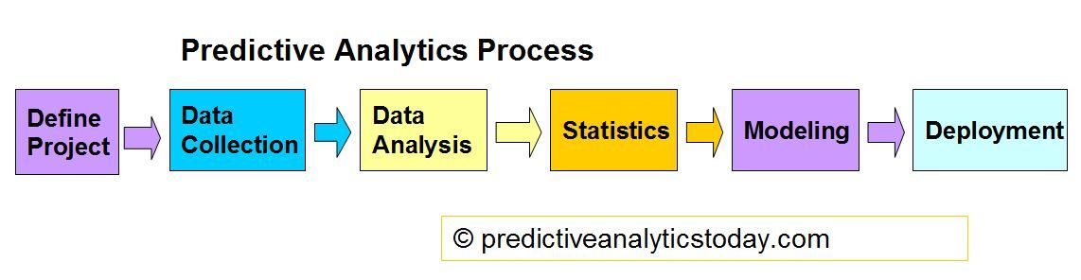

* Step 1: Understand Business Objective
* Step 2: Define Modeling Goals
* Step 3: Select/Get Data
* Step 4: Prepare Data
* Step 5: Analyze and Transform Variables. Random Sampling
* Step 6: Model Selection and Develop Models (Training)
* Step 7: Validate Models (Testing), Optimize and Profitability

**3.2. Software design:**

Go to the Website

Get Global Active Power

Enter the details

The User Interface is very simple and user friendly. The first step is to visit website, then enter all the required data that is asked there and on clicking the submit button you get the Global Active Power result at once Just below the submit button.

4. **EXPERIMENTAL ANALYSIS:**

The household power consumption dataset that describes electricity usage for a single house over four years is collected. Then we identify the energy consumption patterns apply statistical modeling and suggest the user about reduction of power consumption.

**5. FLOWCHART:**

**6. RESULT:**

As a result of being aware of the individual appliances power consumption leads to huge reduction of power consumption as well as money.

Before submitting the values:

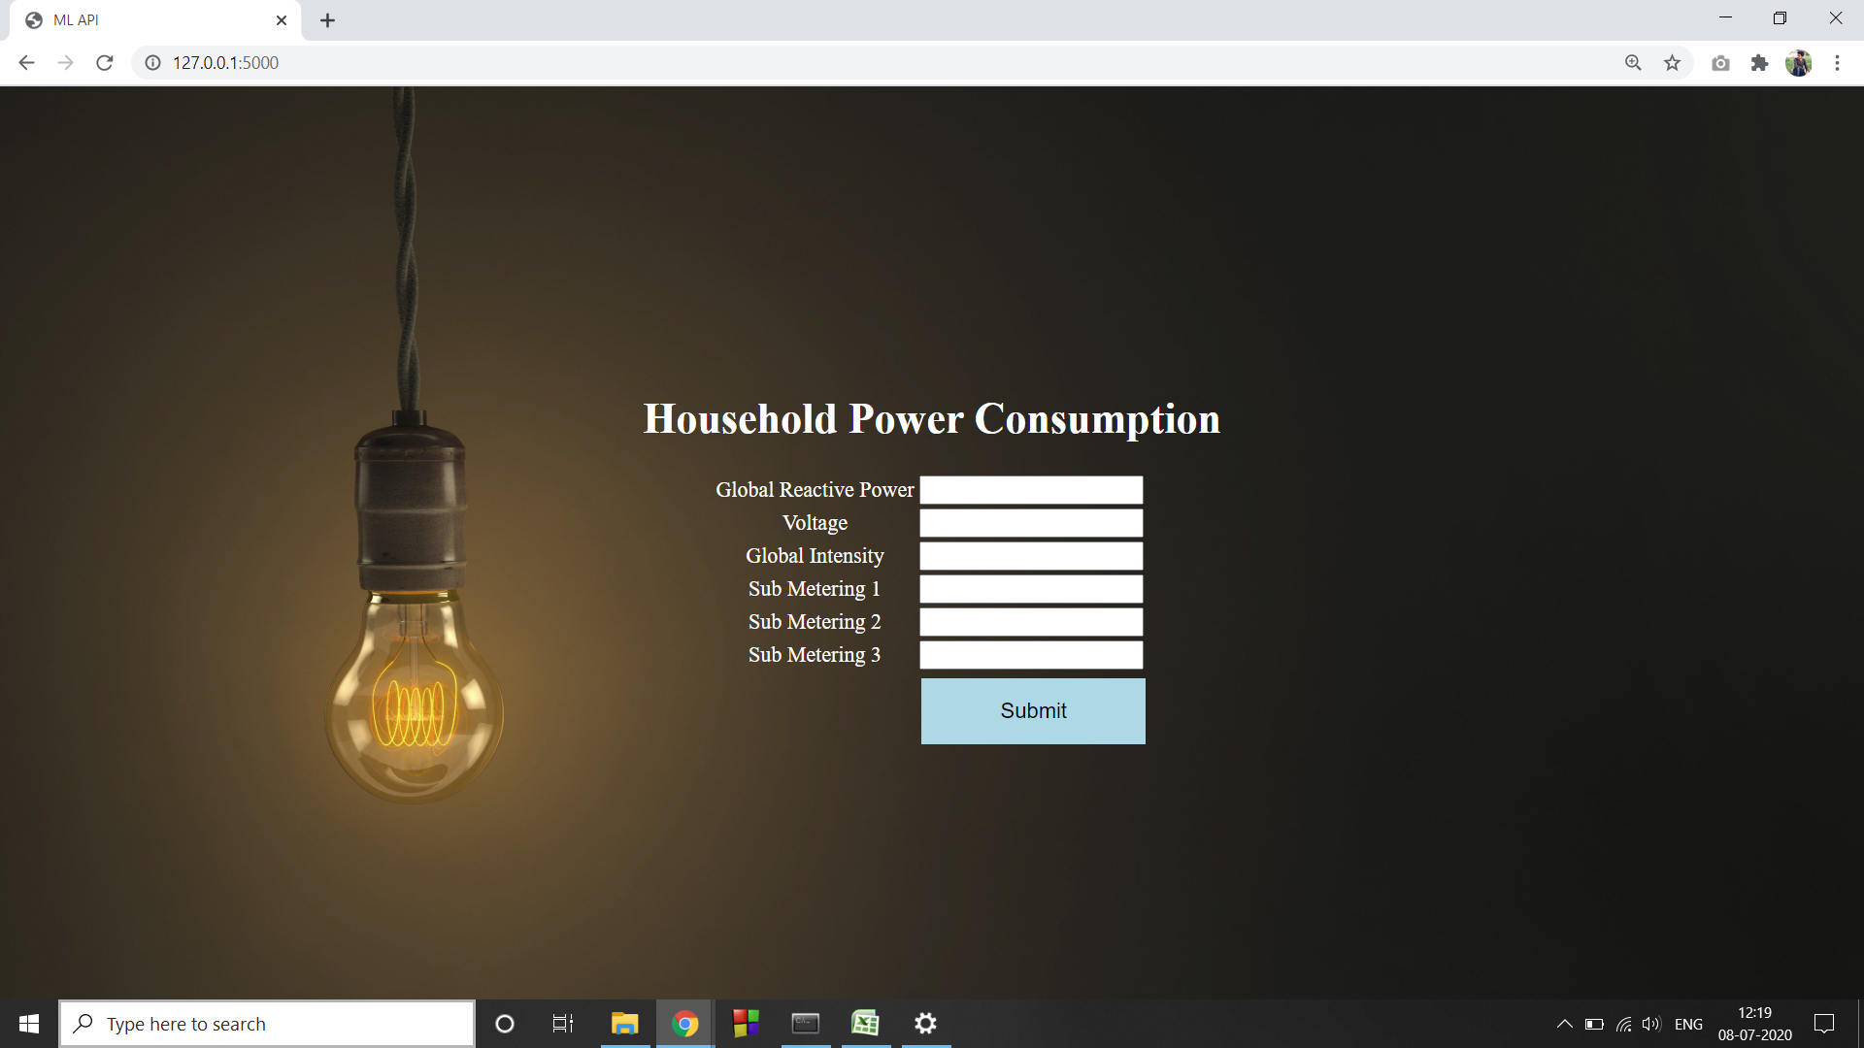

After entering the values and submission:

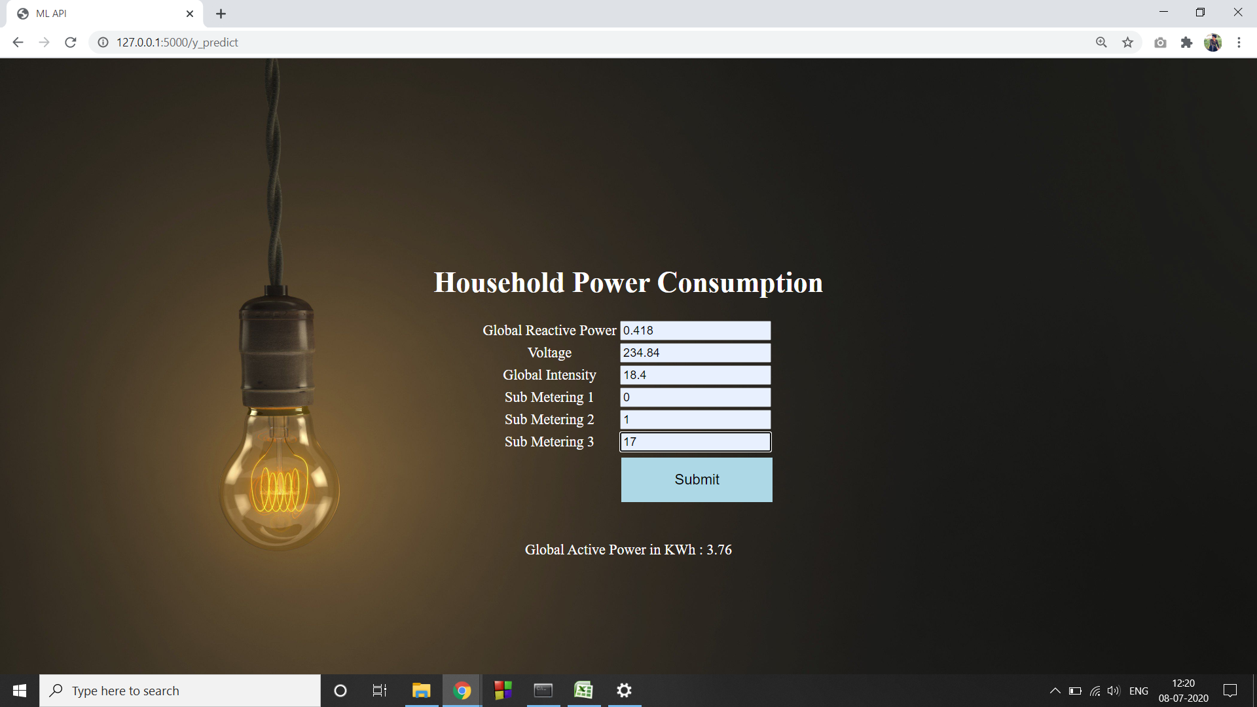

**7. ADVANTAGES AND DISADVANTAGES:**

The advantage is power consumption reduction and money.

The disadvantage is that the prediction might alter due to external factors.

**8. APPLICATIONS:**

The model is very user friendly and that can be used in every house in order to be aware of their power consumption rate. This enables them to be conscious about their usage and in turn helps them to save power and money.

**9. CONCLUSION:**

Therefore, a web application to analyse and visualize the household power consumption data will be very important for the users to create a sustainable environment.

**10. FUTURE SCOPE:**

The same model can also be deployed for other resources such as water, gas etc,. So that we can create a sustainable environment to live in.